Connecting the Dots…with IBM SQL Services
Presentation Handout
Page 1 of 8
Customized SQL Services for objects, devices and users
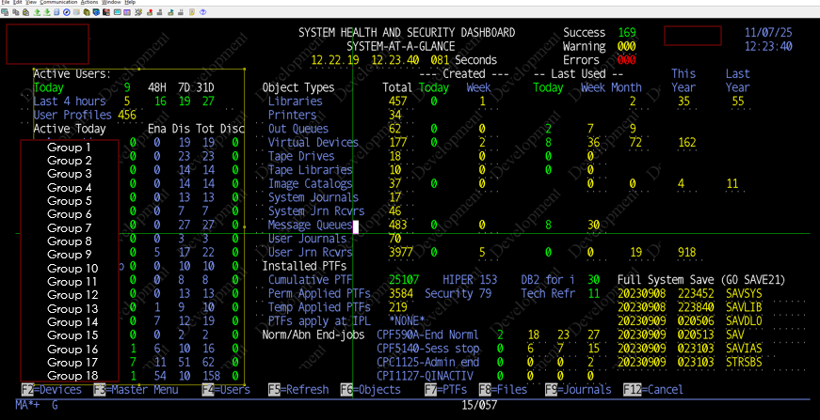1. Libraries on the system
SELECT count(*)
FROM table (qsys2.object_statistics('*ALL', '*LIB’)
2. Who created the new library?
SELECT *
FROM table (qsys2.object_statistics('*ALL', '*LIB’) )
WHERE date(objcreated) = date(current_date)
3. How many virtual devices have been created in the last 7 days?
SELECT count(*)
FROM table (qsys2.object_statistics('QSYS', '*DEVD') )
WHERE objat00001 like '%VRT%' and
date(objcreated) >= date(current_date - 7 days)
4. How many different users have signed on in the last 9 hours?
SELECT count(*)
FROM user_info
WHERE time(previous_signon) >= time(Current_time - 9 hours) and date(previous_signon) = date(current_date)
Connecting the Dots…with IBM SQL Services cont…
Presentation Handout
Page 2
5. How many disconnected sessions are there on the system now?
SELECT count(*)
FROM TABLE(QSYS2.ACTIVE_JOB_INFO(DETAILED_INFO=>'ALL’))
WHERE job_type <> 'SYS' and job_status = 'DSC'
A Sample of the different types of jobs on your system
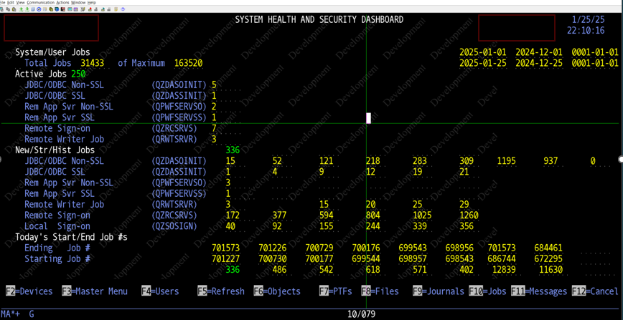
6. List of ODBC/JDBC unencrypted jobs (data jobs) in subsystem QUSRWRK
QZDASOINIT
SELECT count(*)
FROM TABLE(QSYS2.ACTIVE_JOB_INFO(
JOB_NAME_FILTER => 'QZDASOINIT',
SUBSYSTEM_LIST_FILTER => 'QUSRWRK’))
7. List of IFS unencrypted jobs in subsystem QUSRWRK (Rem App Svr)
QPWFSERVSO
SELECT count(*)
FROM TABLE(QSYS2.ACTIVE_JOB_INFO(
JOB_NAME_FILTER => ‘QPWFSERVSO',
SUBSYSTEM_LIST_FILTER => 'QUSRWRK’))
Connecting the Dots…with IBM SQL Services cont…
Presentation Handout
Page 3
8. List of ODBC/JDBC encrypted jobs (data jobs) in subsystem QUSRWRK
QZDASSINIT
SELECT count(*)
FROM TABLE(QSYS2.ACTIVE_JOB_INFO(
JOB_NAME_FILTER => 'QZDASSINIT',
SUBSYSTEM_LIST_FILTER => 'QUSRWRK’))
9. List of IFS encrypted jobs in subsystem QUSRWRK (Rem App Svr)
QPWFSERVSS
SELECT count(*)
FROM TABLE(QSYS2.ACTIVE_JOB_INFO(
JOB_NAME_FILTER => ‘QPWFSERVSS',
SUBSYSTEM_LIST_FILTER => 'QUSRWRK’))

Connecting the Dots…with IBM SQL Services cont…
Presentation Handout
Page 4
Examples of using an IBM SQL Service with output from WRKDEVSTS *PRINT
(saved to a database file)
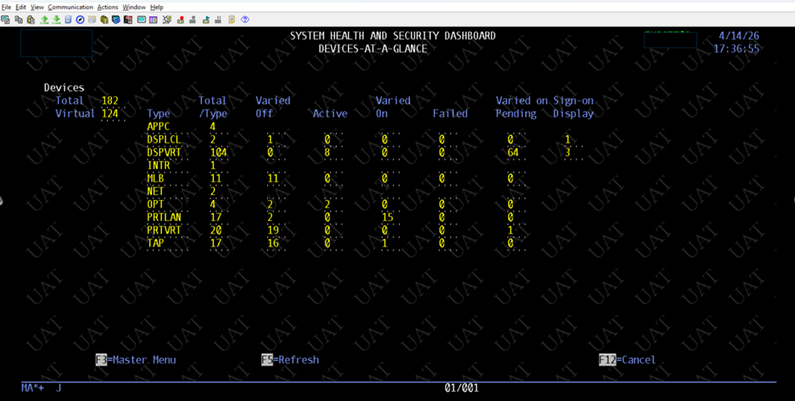
10. List of Local Devices at a sign-on screen
*** This would be your system console (DSP01) at a sign-on screen.
SELECT substr(count(*),1,4)
FROM table (qsys2.Object_Statistics('QSYS', '*DEVD') ) as a
JOIN tmp_WRKCFG as b
ON a.objname = b.tmp_devdes
WHERE a.objat00001 like '%DSPLCL%’
and b.tmp_devsts = 'SIGNON DISPLAY’
11. List of ACS (or other 5250 Emulation) Devices currently in use (*ACTIVE)
(joined with output from WRKDEVSTS *PRINT saved to an database file)
SELECT substr(count(*),1,4)
FROM table (qsys2.object_statistics('QSYS', '*DEVD') ) as a
JOIN tmp_WRKCFG as b
ON a.objname = b.tmp_devdes
WHERE a.objat00001 like '%DSPVRT%’
and b.tmp_devsts = 'ACTIVE'
Connecting the Dots…with IBM SQL Services cont…
Presentation Handout
Page 5

12. List of Optical (DVD) Varied *OFF devices
SELECT substr(count(*),1,4)
FROM table (qsys2.object_statistics('QSYS', '*DEVD') ) as a
JOIN tmp_WRKCFG as b
ON a.objname = b.tmp_devdes
WHERE a.objat00001 like '%OPT%'
and b.tmp_devsts = 'VARIED OFF.

13. List of LAN Printers Varied *ON devices
SELECT substr(count(*),1,4)
FROM table (qsys2.object_statistics('QSYS', '*DEVD') ) as a
JOIN tmp_WRKCFG as b
ON a.objname = b.tmp_devdes
WHERE a.objat00001 like '%PRTLAN%’
and b.tmp_devsts = 'VARIED ON'

14, List of System Limits messages for the last 15 days
Spool files or Maximum number of all rows in a file/table
A. 15000-Limit on Maximum number of rows: 4,294,652,340
B. 19002-Limit on Spool files: 2.610,000
SELECT *
FROM TABLE (QSYS2.HISTORY_LOG_INFO(START_TIME
=> CURRENT DATE - 15 days))
WHERE message_id = 'SQL7062’ and
date(messa00003) > current_date - 15 days
Find out how many more alerts there are to come…
*** Refer to ibm.biz/DB2forIAlerts for more detail

Connecting the Dots…with IBM SQL Services cont…
Presentation Handout
Page 6

Customized SQL Services for PTFs
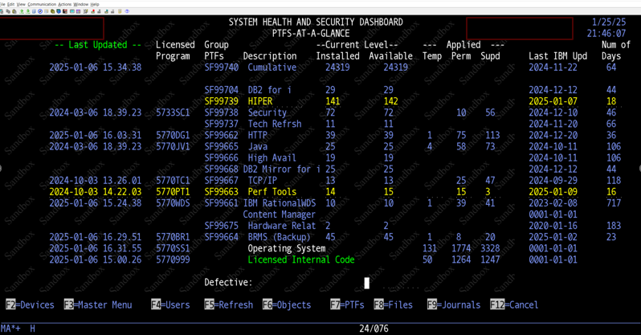
15. When has the last CUM PTF package been installed?
Select date(stattime), time(stattime)
FROM ptf_info
WHERE licpgm ='5770SS1’
and ptfid like 'TC%’
ORDER BY STATTIME desc fetch first 1 rows only
16. When was an operating system (OS) PTF applied to your system?
Select licpgm, lic_term, installed, feature
FROM qsys2.License_Info
WHERE Licpgm = '5770SS1' and feature = '5050’
and installed = 'YES';

Connecting the Dots…with IBM SQL Services cont…
Presentation Handout
Page 7

17. When was the last DB2 for i PTF package installed?
Select max(PTF_Group_Level)
FROM QSYS2.Group_PTF_Info
WHERE PTF_Group_Name = 'SF99704' and
PTF_Group_Status = 'INSTALLED’

18. When was the Java PTF Group last updated by IBM?
Select GRP_ID, substr(GRP_LVL,1,3), substr(GRP_IBMLVL,1,3),
GRP_lstupd, days(current_date) - days(GRP_lstupd)
FROM SYSTOOLS.Group_PTF_Currency
WHERE GRP_ID = 'SF99665’
and GRP_SysSts = 'INSTALLED';

Connecting the Dots…with IBM SQL Services cont…
Presentation Handout
Page 8
Example of a DEFECTIVE PTF identified by IBM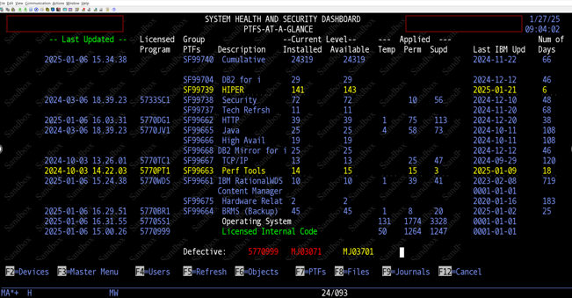
19. Only DEFECTIVE PTFs applied already to your system will be shown
Select GRP_ID, substr(GRP_LVL,1,3), substr(GRP_IBMLVL,1,3),
GRP_lstupd, days(current_date) - days(GRP_lstupd)
FROM SYSTOOLS.Group_PTF_Currency
WHERE GRP_ID = 'SF99665’
and GRP_SysSts = 'INSTALLED';

